**About**  
The IEEE Photonics Society – Student Branch Chapter at MIT BLR is dedicated to advancing photonics and optics through innovation, research, and collaboration. We explore diverse applications, from fiber-optic communications to solar energy and LED technology. Our mission is to drive technological advancements, foster professional growth, and create a dynamic learning environment through expert-led workshops, seminars, and hands-on projects. Our vision is to build a strong foundation in photonics within our college community, inspiring students to explore and contribute to this exciting field. Join us in exploring the world of photonics!

**Core Committee:**

🔹 **Chair** – *Bhoomi Verma*

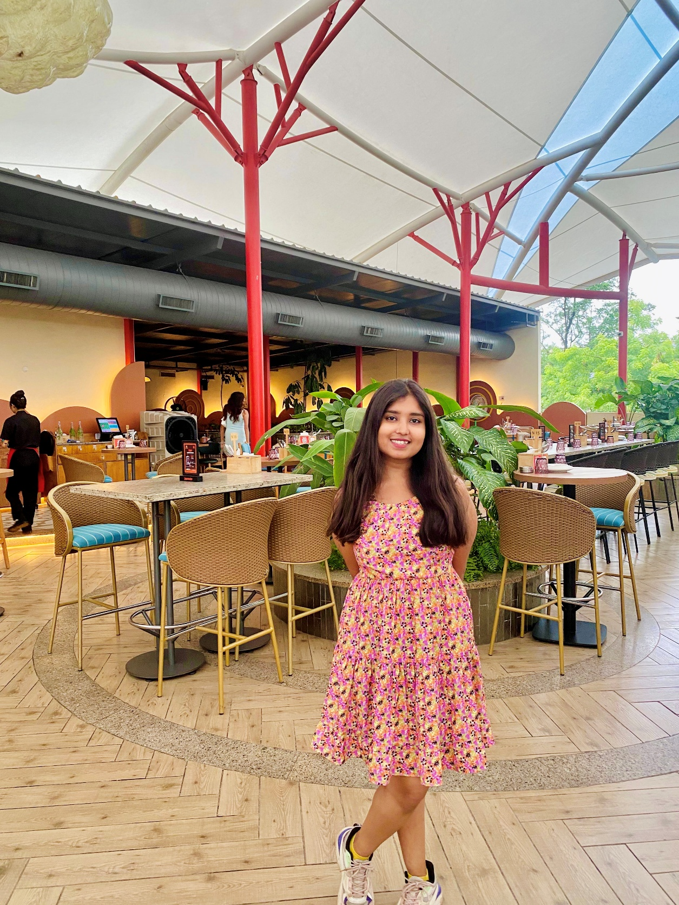

🔹 **Vice Chair** – *Veid Mahesh Patange*

🔹 **Secretary** – *Pramiti T D*

🔹 **Joint Secretary** – *CKD Sumukh*

🔹 **Executive Head** – *Harshita V Raghavan*

🔹 **Marketing Head** – *Gouri Jayan*

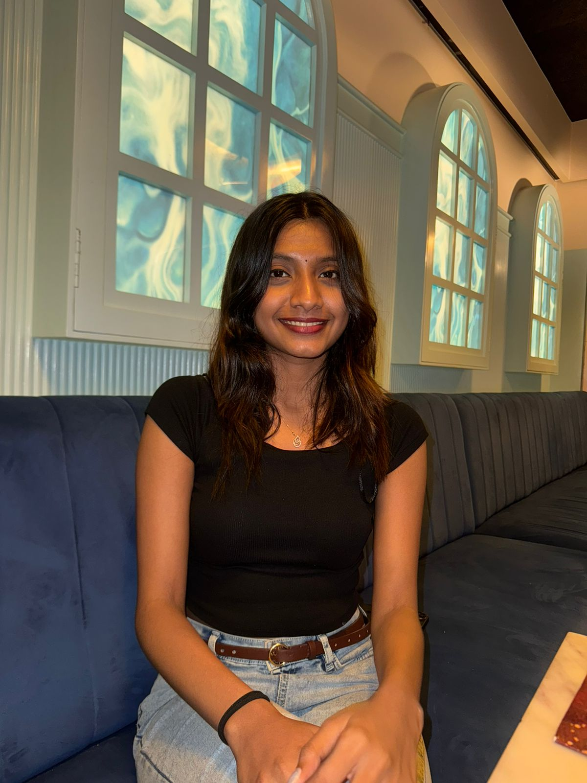

🔹 **Social Media Head** – *Anagha M Nair*

